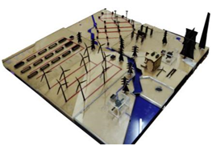

**ENERGY** - Renewable source of energy from which electricity can be produced are – **Solar Energy** where energy is produced using sunlight, **Wind Energy** where wind turbines rotate by the motion of air to generate electricity, **Geothermal Energy** that comes from the Earth’s crust where steam is extracted to generate electricity, **Biomass** which includes natural products like wood, manure, organic waste – this waste is burned to produce electricity, **Hydro Energy** uses kinetic energy of flowing water to rotate the turbines and generate electricity.

However **Thermal Energy** that is derived from coal is most efficient source of energy. There is a Grid System all over India where the electricity can be transmitted from state to state despite of having different production units. When it comes to generating energy at a domestic level Hybrid System can be used. This system harness Solar and wind energy to produce electricity.

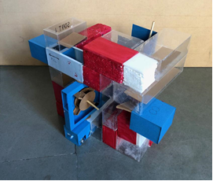

**AIR** - Earth’s atmosphere is a thin blanket of gases and tiny particles—together called air. Like all gases, air takes up space. These gases that make up our air are packed closer together near the Earth’s surface than at higher elevations.

All living things need some of the gases in air for life support. In particular, all organisms rely on oxygen for respiration—even plants require oxygen to stay alive at night or when the Sun is obscured. Plants also require carbon dioxide in the air for photosynthesis. All weather happens in the atmosphere. The atmosphere has many other important roles as well. These include moderating Earth’s temperatures and protecting living things from the Sun’s most harmful rays. Somehow air is getting polluted by human activities which are harmful for the environment.

Air pollution refers to the release of pollutants into the air. It is the mixer of solid particles and gases emitted from vehicles, chemical factories and electrical appliances. Greenhouse effect is due to air pollution the main air pollutants are PM2.5, O3, PM10, SO2, NO2, CO, PB, CH4. Air pollution effects on human health are asthma, lung cancer, heart disease, chronic respiratory disease and even damage to brain, nerves, liver and kidneys.

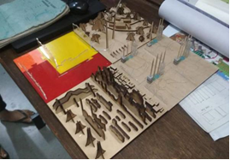

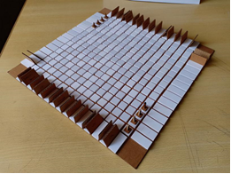

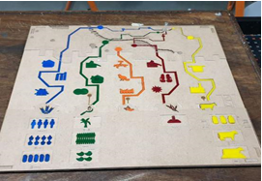

**FOOD** - Food is any substance consumed to provide nutritional support for an organism. It is usually of plant or animal origin, and contains essential nutrients, such as carbohydrates, fats, proteins, vitamins, or minerals. The substance is ingested by an organism and assimilated by the organism’s cell to provide energy, maintain life, or stimulate growth.

Historically, humans secured food through two methods: hunting and gathering and agriculture. Today, the majority of the food energy required by the ever increasing populations of the world is supplied by the food industry.

Main food source are mostly origin from plants. Some food is obtained directly from plants; but even animals that are used as food sources are raised by feeding them food derived from plants. Mainly food is categorized in five types like Dairy, fruits, vegetables, Spices, grains and meat.

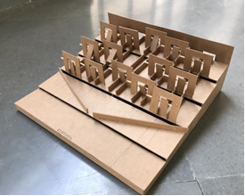

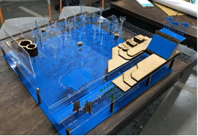

**WATER** - Water is our most precious resource, supporting all life on Earth. It is a transparent, colorless and odorless chemical substance which is the main constituent of Earth’s streams, lakes, and oceans, and the fluids of most living organisms. It is vital for all known forms of life. Through this process, we have been trying to develop a deeper understanding on the process chains of water from its source to its usage.

The main categorization is based on the source, supply and usage of water. The study helped us to know what are the available water sources on Earth and how does it get distributed proportionately for irrigation, industries and household usage. Also we came across the processes for clarification of water that are done before the water reaches the house and also studied the sewage water management systems.

Rain water harvesting and its methods were also studied to help the constantly undergoing ground water level and trying to save the national resource for the future.

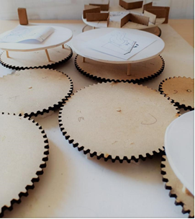

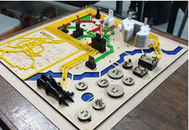

**WASTE** - Waste is anything which is not useable in its original state, commonly known as trash. We deal with n numbers of waste in our entire day. It can be from a broken pencil to an unused car, can be categorized under waste.

Waste has typically two main segregations:

**Solid Waste** - These include all the items commonly seen in a trash can.

**Liquid Waste** - These include wastewater, gases, or sludge’s and hazardous household liquids.

Ahmedabad belongs to one of the cities which produce high amounts of waste. The management is done by the local municipal body (AMC). Ahmedabad Municipal Corporation has divided the system into ‘solid waste’ and ‘liquid waste’ management systems. We spilt into groups which looked into these two categories in detail. This was to get a closer idea of the waste management strategies followed by the city on an urban level. To cover 464 km square area, the municipal body has divided the city in to six zones. We studied the new west zone, the journey from trash can to decomposition. There are two trash cans provided by the AMC to each community to societies. Green for wet waste and Blue for dry waste. There is a truck which goes around collecting these trash cans having two separate chambers where 70% is occupied by wet waste and 30% dry waste. Every zone has local segregation plant then it is transferred to the main dumpsite ‘Pirana’. The problem with Pirana is there are all kinds of trash dumped together which is making it toxic and turned the area into brownfields.

